FOR IMMEDIATE RELEASE
Date: July 29, 2021
Pinckneyville Community Hospital Welcomes Rural Health Experience Student

Pinckneyville, Illinois – July 29th, 2021—
Pinckneyville Community Hospital hosted Olivia Bohleber, University of Illinois student, as a Rural Health Experience (RHE) Student. The RHE program is an innovative, three to five day opportunity for health professions students to observe rural healthcare providers and their communities. RHE provides shadowing experiences in multiple healthcare departments, including but not limited to: family medicine, physical therapy, pharmacy, behavioral health, emergency department, laboratory, imaging, respiratory, various specialty clinics, local health department and local ambulance service. The RHE student can also get the opportunity to meet with administration and observe inter-professional team meetings.
The objectives for the RHE program are to learn about the social and health characteristics, needs, and resources of a specific rural Illinois community and the roles and responsibilities of various healthcare providers in a rural community. The student can then reflect on a future career as a healthcare provider in a rural community. Students also get the chance to explore the community in the evenings.
Olivia Bohleber states this experience opened her eyes to the need of healthcare in rural areas. She quotes, “By having this experience, I was able to witness first-hand how providers worked in a rural area and see the roles they undertook in their positions.” Bohleber spent four days at Pinckneyville Community Hospital shadowing various departments. Gloria Przygoda, South Central AHEC Director, states, “This is a great program to get students who are interested in healthcare first-hand experience in multiple departments, exposing them to the unique and exciting characteristics of rural healthcare.”
Students of all health disciplines are encouraged to apply for the RHE program. Students must have completed sophomore year of undergraduate studies by the start of the program. Preference goes to students from rural Illinois communities with interest in serving a rural community in the future. For more information visit https://ncrhp.uic.edu or contact Gloria Przygoda, South Central Illinois AHEC Director at 618-357-8878.

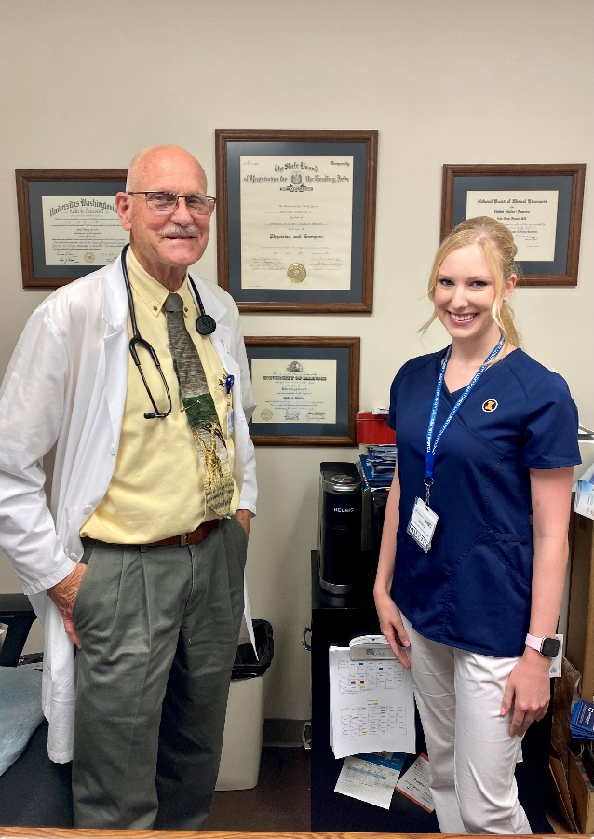
Pictured above are Dr. Fozard of Pinckneyville Community Hospital Family Medical Center and Rural Health Experience Student, Olivia Bohleber.

# # #

Pinckneyville Community Hospital is a critical access hospital that is leading the way to a healthier tomorrow. The hospital provides local access to quality and convenient healthcare by providing a 24-hour emergency department; 17 bed medical floor offering inpatient, observation and swing bed program; Family Medical Center; oncology; surgery; therapies; radiology; laboratory services and over 15 specialty clinics close to home.

